|  |
| --- |
| **Feudalism and the Feudal Relationship** |
| HTC Lesson 2: Cause and Consequence Task |

**TASK:** **Create an organizer like (similar to) the example below. As you read the Feudalism article, fill in the organizer and submit to the Assignment folder. Identify multiple causes and consequences and add key information to explain the nature and problems of Feudalism.**

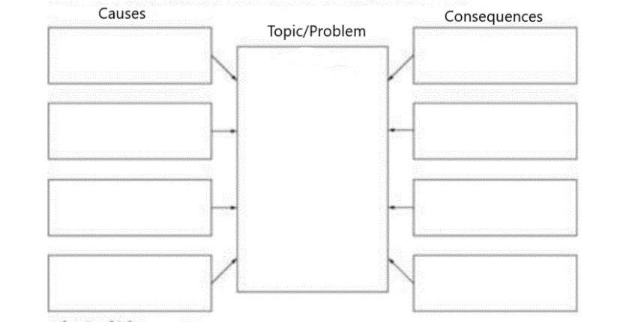

**Reading: Feudalism**

Although the 9th century can be characterized as an age of confusion, the situation was made worse by a renewed series of invasions throughout the century. Vikings from the north, Magyars from the east, and Saracens from the South plundered the continent. The great landowners raised their own armies and built castles to protect the open country. Such resistance on the part of the landowners also had the effect of increasing their authority at the same time that it made them less dependent on the central government.

The wave of invasions came to an end to the 10th century, however, European recovery was slow. Although the barbarians in England, Ireland, and Normandy assimilated themselves to Christianity, those tribes of Eastern Europe were a far more difficult group to absorb. As result of the invasions normal communications and travel were destroyed. It was therefore necessary that local self-sufficiency, which was already strong, was intensified by the needs of security and protection. It was necessary that European society be reorganized so that each area could meet its minimum means from its own resources.

There is little doubt that the chronic absence of any effective central government and the threat of both war and famine contributed to the general awareness of the need for security and protection. The institution known as feudalism appeared in this atmosphere of collapsing central authority, civil war, invasion and overall economic stagnation. The term feudalism refers to that social, political, and economic system that emerged from the experience of the 9th century. Feudalism highlighted the fact that only those men who could guarantee immediate protection and security from a war, invasion, and famine, were the true lords. In other words, feudal society was society dominated by warriors. What people needed most was the assurance that they could depend on others when needed as a result, powerful individuals were recognized as superiors by lesser men who pledged themselves to them, promising them service.

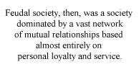

Feudal society, then, was a society dominated by a vast network of mutual relationships based almost entirely on personal loyalty and service. This practice grew out of two primary sources. On the one hand, the tribal bonds characteristic of the invading tribes began to decline due to their Christianization. On the other hand, the fall of Rome and its aftermath led to a general weakening of one's loyalty to the state, which had been characteristic of the later years of the Roman Empire.

So far we have established that feudal society was based on security and protection. Feudalism was also a political, economic, military, and social arrangement. Of course, if we were to ask a medieval king to describe feudalism, he would not really know what it was we were asking of him. The reason is clear. Feudalism is the word used to describe a complex set of relationships which appeared following the reign of Charlemagne. There is no handbook of feudalism. Because of this feudalism is sometimes difficult to describe. Added to this complication, there is a considerable degree of variation as regards how and where feudalism made its first appearance. However, the heartland of the feudal system is in Europe, specifically that area which falls between the Loire and Rhine rivers. In general, feudalism first made its appearance in Western Europe and more slowly in Central and Eastern Europe. Consequently, feudalism first disappeared in the west and more slowly in the east and in Russia.

The network of mutual relationships which together constituted what we have been calling feudal society, enabled warriors to acquire large armies and to rule over territory without necessarily owning the land or having any royal title to their rule. Large groups of vassals would eventually become a professional military class with its own code of conduct. These military organizations appeared as a result of the absence of strong central government.

In the sixth and seventh centuries there involved the custom of individual freemen, who did not belong to any protecting group, to place themselves under the protection of a more powerful freeman. In this way stronger men were able to build up armies and become local political and judicial powers, and the lesser men were able to solve the problem of security and protection. Men who entrusted themselves to others were known as ingenui in obsequio, or "freemen in a contractual relation of dependence." Those who gave themselves to the king were called antrustiones. All men of this type came to be described collectively as vassals.

The landed nobility, like kings, made every effort to acquire as many vassals as they could for the obvious reason that military strength during this period lay in numbers. Of course, it was absolutely impossible to maintain these growing armies on what was provided by the lord's household alone, or to support them by payment. What involved was the practice of granting the vassals land as a benefice or fief. The vassals were expected to live on the land, maintain their horses, and supply themselves with weapons of war. The fief was inhabited by peasants, and the crops that they raised provided the vassal with his means of support.

The whole practice of vassalage involved fealty to the lord. To swear fealty was tantamount to promising to refrain from any action that might threaten the well-being of the lord and to perform personal services for him at his request. The primary service was military duty as a mounted knight. This, of course, could involve a variety of activities: a short or long military campaign, escort duty, standing guard, providing lodgings when the lord traveled through the vassal's territory, or the giving of a gift when the lord's son was knighted or when his eldest daughter married. In general, the vassal owed a number of obligations to his lord. The incidence of bargaining and bickering over the terms of service was great. Eventually, limitations were placed on the number of days a lord could require services from his vassal. For example, in France in the 11th century about forty days of service a year were considered normal. A vassal could also by his way out of military service. The lord, in turn, would apply this payment to the hiring of mercenaries, a practice which proved more efficient but also more costly.

The vassals also expect to give the lord advice when he requested it and to sit as a member of his court. The vassal owed the lord financial assistance when necessary. For example, financial assistance was required if a lord were captured and needed ransom or if he were outfitting himself for a crusade or other military campaign.

Both lord and vassal were bound by honour to abide by the oath of loyalty. It became an accepted custom for a vassal to renounce his loyalty to his lord if the latter failed to protect him from enemies, mistreated him, or increased the vassal's obligations as fixed by the feudal contract. Of course, if a vassal did not live up to his obligations, the lord would summon him to his court, where he would be tried for treachery. If found guilty, the vassal could lose his fief or perhaps his life.

In the early 9th century, bishops and abbots swore oaths of fealty and received their offices from the king as a benefice. The king formerly "invested" these clerics in their offices during a special ceremony. Such a practice eventually provoked a serious confrontation with the Church in the 11th century (the [Investiture Controversy](http://www.knight.org/advent/cathen/08084c.htm)).

A lord also had obligations to his vassals which were very specific. The lord was obliged to protect the vassal from physical harm and to protect him in court. After fealty was sworn the lord provided for the vassal by bestowing upon him a benefice or fief. The fief was usually land necessary to maintain the vassal, but oftentimes the vassal would receive regular payments of money from a lord. This made it possible for a landowner in one area to acquire vassals among the landowners of another. Hopefully you can recognize grounds for future conflict.

In the 9th century a fief varied in size from one or more small villas to agricultural holdings of twenty-five to forty-eight acres. Vast estates were created by the king's vassals, many of whom received benefices consisting of as many as two hundred such holdings. Vassals of the king, strengthened by such large benefices, created their own vassals. These, in turn, created still further vassals of their own. The general effect of such a practice fragmented the land and authority from the highest to the lowest levels by the end of the 9th century. Added to this fragmentation, and the complexities that it produced, there developed a practice of multiple vassalage. That is, one vassal would receive a benefice from more than one lord. This concept lead in the 9th century to the concept of liege homage, that is, the one lord whom the vassal must obey even if it meant the harm of his other masters.

Over time the occupation of land gradually led to claims of hereditary possession. Such a practice became a legally recognized principle in the 9th century and laid the grounds for claims to real ownership. Fiefs given as royal donations became hereditary possessions.

The problem of loyalty was reflected in the ceremonial developments of the act of commendation in which a freeman became a vassal. In the mid-8th century an oath of fealty highlighted this ceremony. A vassal reinforced his promise to his lord by swearing a special oath with his hand on a sacred relic or the Bible. By the 10th and 11th centuries paying homage to the lord involved not only the swearing of such an oath but the placements of the vassal's hands between the lord's and a sealing of the ceremony with a kiss.

As the centuries passed, personal loyalty and service became almost secondary to the acquisition of property. The fief overshadowed fealty, the benefice became more important than vassalage, and freemen began to swear allegiance to the highest bidder only. In other words, the personal relationships embodied in the concept of feudal society as it made its appearance in the 8th and 9th centuries had become, by the 10th an 11th centuries, merely the means for the acquisition of more private property. Feudal society provided stability, security, and protection throughout the period of the early Middle Ages and aided in the development of political centralization during the high Middle Ages. Of course, the political stability promised by the feudal relationship eventually devolved into total anarchy, one result of which was the [One Hundred Years' War](http://www.ku.edu/kansas/medieval/108/lectures/hundred_years_war.html).

Derived from traditional Germanic law, feudal law was very different from Roman law. Roman law was deemed universal because it had been created by a central government for a world empire. Furthermore, Roman law was rational because it was believed to be in accordance with natural laws applicable to all, and it was systematic in that it offered a framework of standards that applied to individual cases. Feudal laws, on the other hand, were local and personal. In the Roman view, the individual as a citizen of Rome owed specific obligations to the state. In the feudal relationship, a vassal owed loyalty and service to a lord according to the terms of their personal agreement.

In the feudal way of things, lords and kings did not make law since they were guided by tradition and precedent. Patterns of landownership were regarded as expressions of ancient and unchanging custom. In general, when conflicts developed between vassal and lord, or between lords, the demand was almost always made for the restoration of customary rights.

Feudal lords were warriors plain and simple. Manual labour or trade was shunned as degrading to men of such high stature. There was only one vocation and that was fighting. Combat demonstrated a lord's honour and his reputation. It was also a measure of his wealth and influence in feudal society. But what does a warrior do when there was no one to fight? By the 12th century the nobility began to stage tournaments in which knights engaged each other in battle in order to prove their skill, courage and honour. The victors in these "celebrations" gained prestige and honour in the eyes of fellow nobles and peasants alike. A code of behaviour, chivalry, evolved from these feudal contests of skill. A worthy knight was expected to exhibit the outward signs of this code of knightly behaviour: bravery, loyalty, respect and courage.

Over time, a religious element was introduced into the warrior culture we have just described. The Church sought to use the fighting spirit of the feudal knight for Christian ends. So, to the Germanic tradition of loyalty and courage was added a Christian component: a knight was expected to honour the laws of the Church in the service of God. A knight was supposed to protect the weak and defend the Church against heretics of all shades. It is no accident that the very ceremony of knighthood was now placed within a Christian framework.